# **Ken Mary – Biography**

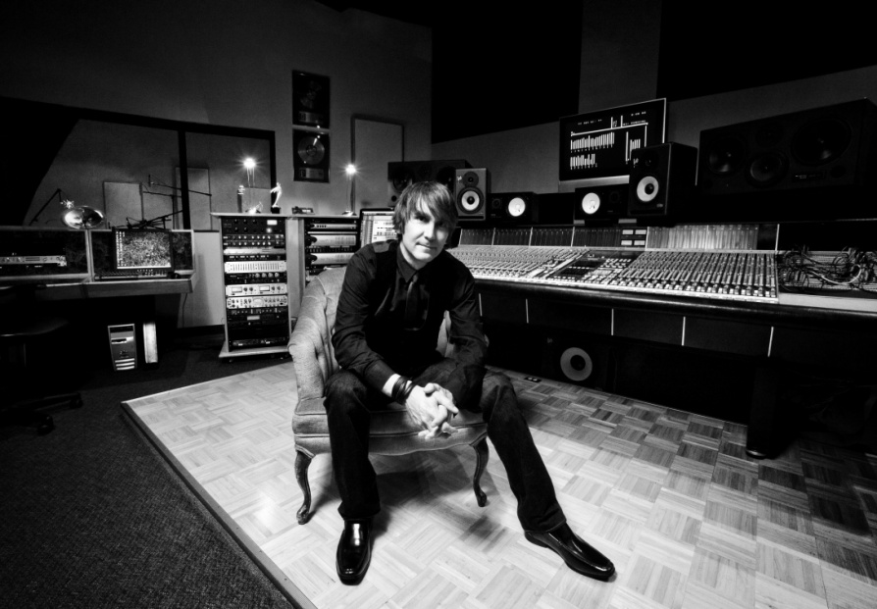

Ken Mary has worked as a music industry executive, producer, engineer, drummer, singer, and writer on over 35 albums that combined have sold over 5 million copies worldwide. Ken's talents have enhanced the work of artists that stylistically span everything from heavy rock to choral music. The list includes internationally recognized artists such as Rock and Roll Hall of Fame inductee Alice Cooper, Trik Turner, Megadeth, LaRue, House of Lords, The Phunk Junkeez, Hall of Fame inductees The Beach Boys, Northern Light Orchestra, Esterlyn, Hall of Fame inductee Gene Simmons from KISS, Daniel Winans, Chris and Conrad, Bob Carlisle (Butterfly Kisses), Debbie Sledge (We Are Family), Ever Stays Red, Dream Theatre keyboardist Jordan Rudess, Ember, Silverline, as well as many new and upcoming artists.

Ken currently serves as President of VSR Music Group, a Capitol distributed record company, and is a long standing member of the Grammy Nomination Committee. Additionally, he owns and runs SonicPhish Productions, a world class SSL recording facility.

Growing up in Seattle, WA, he began his career drumming in his high school rock band, Fifth Angel. The band signed to Epic Records in 1986, the same year in which Ken joined Alice Cooper and moved to Los Angeles. Working to juggle the two commitments, Ken spent the next three years touring with Alice Cooper and promoting Fifth Angel while on tour. He later joined House of Lords, (working closely with Kiss mogul Gene Simmons), and became a highly respected session musician as well, working with a stellar list of world renown producers. In 1995, after several gold albums, MTV top 10 videos, and numerous world tours, Ken began his tenure producing for other artists as well.

Throughout his career Ken has worked alongside and learned from some of the best music producers and engineers in the world including industry giants Andy Johns (Led Zepplin), Michael Wagener (Ozzy Osbourne, Janet Jackson, Extreme), Howard Benson (P.O.D.), Terry Date (Rage Against the Machine, White Zombie), Bill Kennedy (Nine Inch Nails, Megadeth), Mick Guzowski (Mariah Carey), Mac (Queen), Garth Richardson (Rage Against the Machine, Chevelle), and Desmond Child (Ricky Martin, Aerosmith).

Over his career, Ken has racked up an impressive list of radio hits in each of the last four decades which includes 8 Billboard Top 40 hits, 11 Top 10 hits in the CBA market, and numerous hits on charts including Radio and Records, New Music Weekly, AOL Music, and most recently the #1 Top 40 Hit by Ember “The Deep End”, which surpassed Daughtry and Lady Gaga in national airplay and spent over 10 weeks at #1 (2010), the #1 Silverline hit “Broken Glass” (2011), and the #1 Silverline hit “Shine A Light”, and the #2 Silverline hit “Voices in the Night” (2011). Having experience in the Television industry as well, Ken won a national Telly Award for his work as musical producer and director for the cable television series “Reality Rules." He has also recorded for and appeared in three episodes of the #1 ABC hit television sitcom “Full House”, now in syndication.

A partial list of the record labels and corporations Ken has worked with include RCA, MCA, Epic, CBS, Benson, Roadrunner, JVC, Atlantic, DGC, BMG, Relativity, Organic, Invincible, Reunion, REX, Fox, Universal, EMI, Trump Enterprises, (yes, as in The Donald), TBN, Zebra, Provident, Reunion, Sony/BMG, Suburban Noise, BEC, and ABC Family.